Input Mask and Validation Rules

Input Mask 1 and Validation Rule 1 (Both for GPA on Students Table) 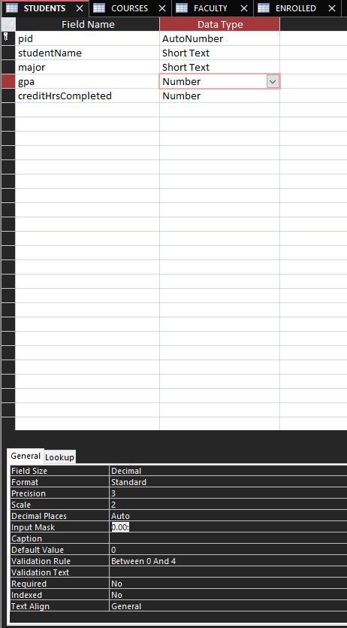

Input Mask 2 (Email for Faculty Table)
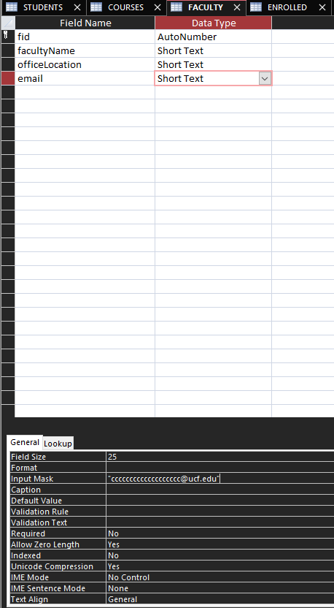

Validation Rule 2 (Grade for Enrolled Table)
